

**Experiment no : 03**

**: Java Script Basic**



**Aim**

(1) (Using var , let , const )write program for addition, subtraction,divisionand multiplication.

**:**

**Code**

**Html :**

**code**

<!DOCTYPE html>

<html>

<head>

<meta charset=utf-8 />

<title> Mathematics Operations </title>

<link rel="stylesheet" href="index.css">

<style type="text/css">

body {margin: 30px;}

</style>

<script src="index.js"></script>

</head>

<body>

<h1>1. (Using var , let , const )write program for addition, subtraction,

division and multiplication</h1>

<form>

1st Number : <input type="number" id="firstNumber" style="width: 20em;" placeholder="Enter the number"/><br>

2nd Number: <input type="number" id="secondNumber" style="width: 20em;" placeholder="Enter the number"/><br>

<div class="operations">

<input type="button" onClick="multiplyBy()" Value="Multiply" />

<input type="button" onClick="divideBy()" Value="Divide" />

<input type="button" onClick="addBy()" Value="Add" />

<input type="button" onClick="subBy()" Value="Substract" />

</div>

</form>

<p>The Result for <span id = "operation">NAN</span> is : <br>

<span id = "result">0</span>

</p>

</body>

</html>

JAVASCRIPT CODE:

**function multiplyBy()**

**{**

**let num1 = document.getElementById("firstNumber").value;**

**let num2 = document.getElementById("secondNumber").value; document.getElementById("operation").innerHTML = "Multiplication";**

**document.getElementById("result").innerHTML = num1 * num2;**

**}**

**function divideBy()**

**{**

**var num1 = document.getElementById("firstNumber").value;**

**var num2 = document.getElementById("secondNumber").value; document.getElementById("operation").innerHTML = "Division";**

**document.getElementById("result").innerHTML = num1 / num2;**

**}**

**function addBy()**

**{**

**const num1 = document.getElementById("firstNumber").value; const num2 = document.getElementById("secondNumber").value; document.getElementById("operation").innerHTML = "Addition";**

**document.getElementById("result").innerHTML = +num1 + +num2;**

**}**

**function subBy()**

**{**

**let num1 = document.getElementById("firstNumber").value;**

**let num2 = document.getElementById("secondNumber").value; document.getElementById("operation").innerHTML = "Substraction";**

**document.getElementById("result").innerHTML = num1 - num2;**

**}**

**:**



**Output**

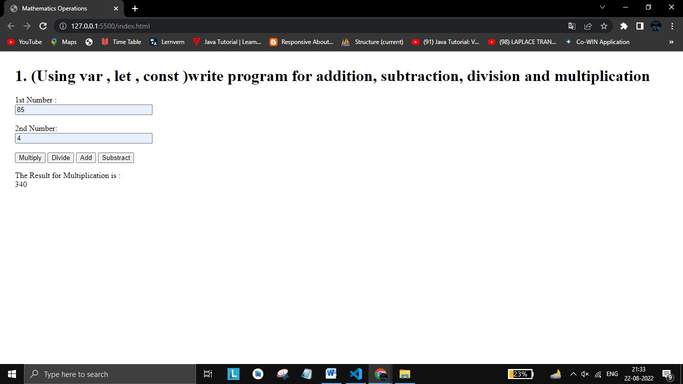

(2) (using conditions FOR, IF ELSE, Break, Continue) write a codefor Persons age is eligible for

**:**

**HTML**

**Code**

<!DOCTYPE html>

<html lang="en">

<head>

<meta charset="UTF-8">

<meta http-equiv="X-UA-Compatible" content="IE=edge">

<meta name="viewport" content="width=device-width, initial-scale=1.0">

<script src="index.js"></script>

<title>Election Age Verification</title>

<style type="text/css"> body {margin: 30px;}

</style>

</head>

<body>

<h1 style="font-size: 25px;">2. (using conditions

FOR, IF ELSE, Break, Continue) write a code for Persons age is eligible for Voting or not.</h1>

<form>

Enter The Age : <input type="number" id="age" />

<input type="button" onClick="ageBy()" Value="Check" />

</form>

<p>The Result is : <br>

<span id = "result"></span>

</p>

</body>

</html>



**Javascript Code :**

function ageBy()

{

let age = document.getElementById("age").value; if (age >=21) {

document.getElementById("result").innerHTML = "You Can Vote In the Election";

}

else if (age >=15){

document.getElementById("result").innerHTML = "You are a teenager and cannot vote";

}

else if (age >=10){

document.getElementById("result").innerHTML = "You are too young to vote";

}

else {

document.getElementById("result").innerHTML = "You are still a baby";

}

}

**:**



**Output**

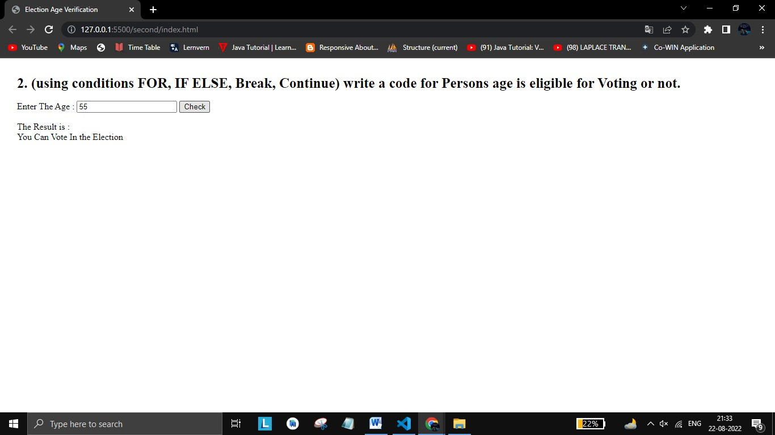

(3) LOOPING (While Loop , DO-while LOOP , Switch Case) Write aProgramto find grade of student

Html code:

<!DOCTYPE html>

<html lang="en">

<head>

<meta charset="UTF-8">

<meta http-equiv="X-UA-Compatible" content="IE=edge">

<meta name="viewport" content="width=device-width, initial-scale=1.0">

<script src="index.js"></script>

<link rel="stylesheet" href="index.css">

<title>Grades Of Students</title>

<style type="text/css"> body {margin: 30px;}

</style>

</head>

<body>

<h1 style="font-size: 25px;">3. LOOPING (While

Loop , DO-while LOOP , Switch Case) Write a Program to find grade of student .</h1>

<form>

Enter The Marks : <input type="number" id="marks" name="score" /><br>

<input type="button" onClick="gradeBy() ; isEmpty()" Value="Check" class="check1" style="margin-left: 5px;"/>

</form>

<div class="result">

<p>The Result is :

<span id = "result" style="color: blue;">Please Enter The Score First</span>

</p>

</div>

</body>

</html>



**Javascript Code :**

function gradeBy()

{

let score = document.getElementById("marks").value; switch (true)

{

case (score <= 100 && score >= 90):

document.getElementById("result").innerHTML = "Your Grade Is A";

break;

case (score <= 89 && score >= 80): document.getElementById("result").innerHTML = "Your Grade Is B";

break;

case (score <= 79 && score >= 70): document.getElementById("result").innerHTML = "Your Grade Is C";

break;

case (score <= 69 && score >= 60): document.getElementById("result").innerHTML = "Your Grade Is D";

break;

case (score <= 59 && score >= 50): document.getElementById("result").innerHTML = "Your Grade Is E";

break;

case (score <= 49 && score >= 35): document.getElementById("result").innerHTML = "Just Pass ";

break;

case (score <= 34 && score >= 0): document.getElementById("result").innerHTML

= "You are Failed "; break;

case (score > 100 && score < 0 ): document.getElementById("result").innerHTML

= "Invalid Score"; break ; default:

return document.getElementById("result").innerHTML = "Invalid Score";

}

}

function isEmpty()

{

if(document.getElementById("marks").value.length == 0)

{

alert("Please Enter Marks First !!");

document.getElementById("result").innerHTML = "Invalid Score";

}

}

**:**



**Output**

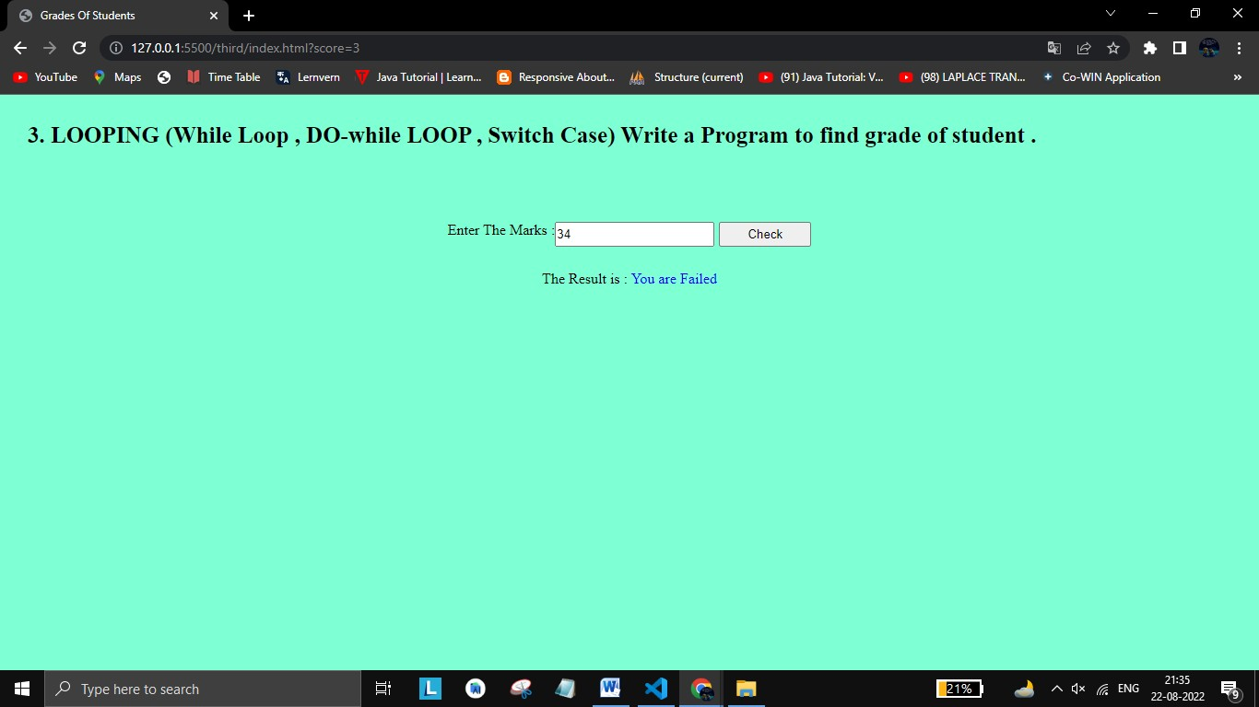

**: Therefore we have successfully implemented basics of javascript.**

**Conclusion**

